**Title**: Transfer Window System

**Project description** : Our project is about football transfers. We have Admin – FIFA and other football clubs. Clubs can send money to other clubs.   
  
**Scenarios** :  
**USE CASE 1**

If you log in as a football club then you can:

1. See information about club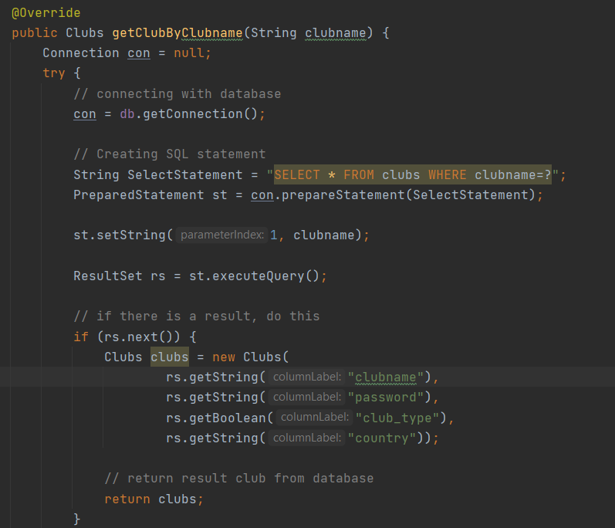
2. Show budget of this club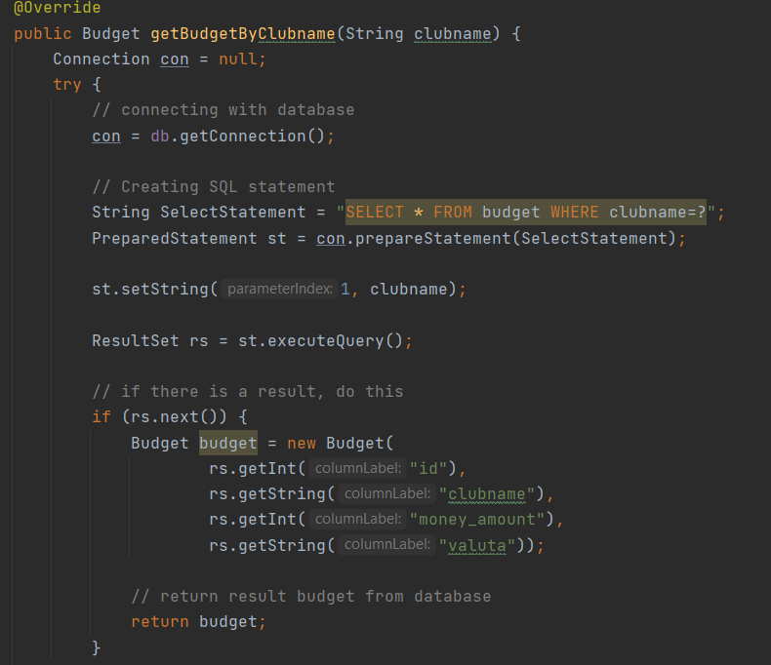
3. Transfer money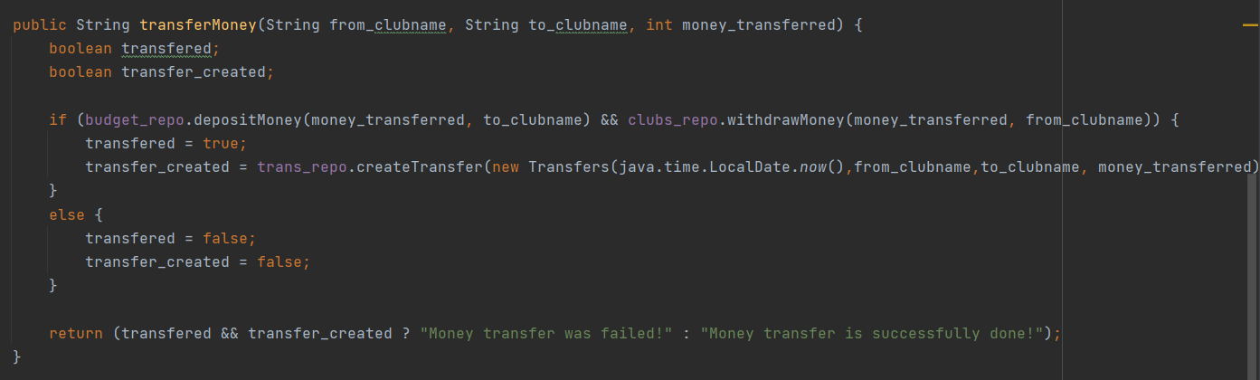

**USE CASE 2**  
  
If you log in as a FIFA(Admin):

1. Show information about FIFA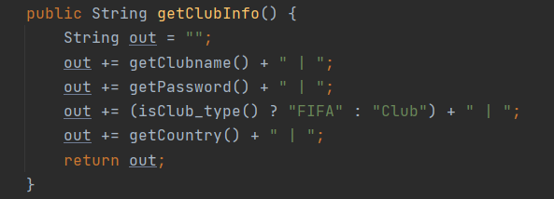
2. Create new club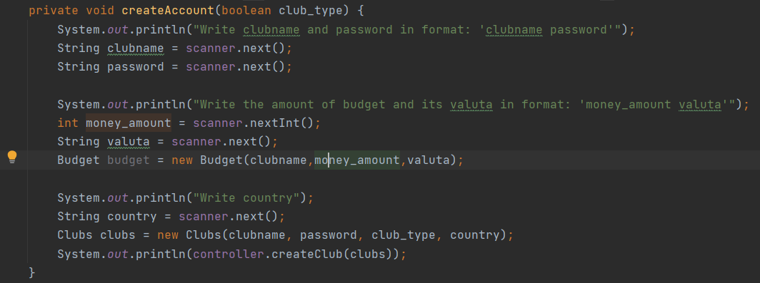
3. See information about other club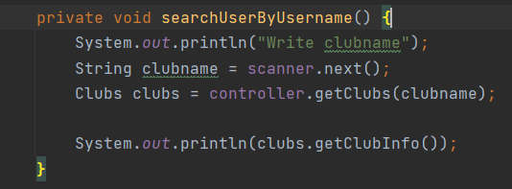
4. Create new Admin 